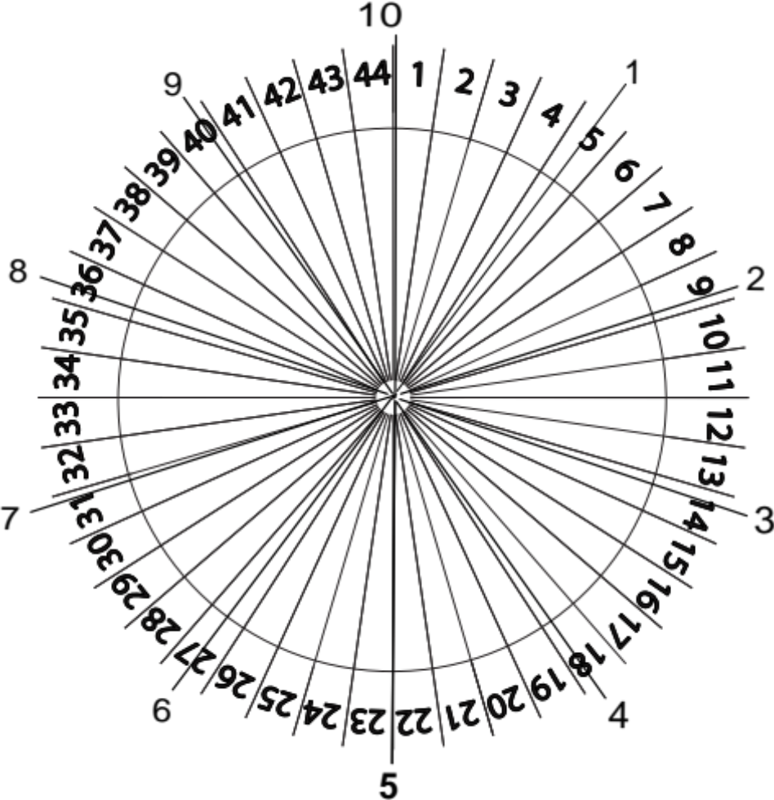

Base 10 Markings superimposed on Base 44 - can be useful if you have a base 10 dial system only but want to use base 44 rates to fine tune your broadcast

Malcolm Rae apparently created base 44 to fine tune radionics broadcasts – it was said that if the emotional body or astral level is involved it is more subtle and complex and requires finer tuned broadcasts so that the resonance can fit more deeply like a key to a door

